The Evolution of State-Local Balance Sheets in the US, 1953-2013
Amanda Page-Hoongrajok, Arjun Jayadev and J. W.. Mason
State and local debt in the United States more than doubled as a share of GDP between 1953 and 2007. Using a historical accounting framework, we find that there is no straightforward relationship over time between state and local deficits and debt growth. We find that only 17 percent of the variation in aggregate state-local debt ratios comes from variation in the fiscal balance. This is especially true in the 1980s, the period of most rapid increase in state-local debt ratios. Before 1980, there were small but persistent deficits, but stable debt ratios. In the 1980s, state and local sectors shifted toward budget surpluses but saw rising debt ratios. This is explained by a faster pace of asset accumulation. Our results demonstrate the autonomy of balance sheet variables and suggest that changing debt ratios cannot be explained by real income and expenditure flows.

Introduction
Like most sectors of the US economy, state and local governments have seen a long-term increase in credit-market debt, from about 8 percent of GDP in 1950 to 17 percent in 2013.While even the latter figure is small compared with federal-government and household debt, it is not trivial. Municipal bonds are important assets in financial markets. On the liability side, state and local debt operates as a political constraint for public officials at the state level and often plays a prominent role in public discussions of subnational spending. Many popular and media accounts of local budgets refer to an upcoming debt crisis and the need therefore to reduce public employee wage increases and limit pension entitlements.
Despite this there has been little work to understand the long-term causes for the increase in state and local debt. The purpose of this paper is to address this lacuna and to describe the historical evolution of state and local government balance sheets. Further, we situate this evolution in a larger discussion of the relationship between financial positions and real income and payments flows.
A central fact often neglected in these discussions is the large asset positions of state and local governments. Unlike the federal government, many local governments and all state governments are substantial net creditors in financial markets. While state and local debt has increased over the past 50 years, the increase in financial assets has been much larger, especially for state governments; the net financial wealth of state governments has increased from less than 5 percent of GDP in the early 1960s to over 20 percent in 2007. Several implications follow. First, there is not necessarily any relation between state and local borrowing and fiscal deficits, and it is wrong to treat an increase in the (gross) debt ratio as evidence of (net) dissaving. In fact, as we show, fiscal balances and debt ratios often vary together, not inversely. Second, when states seek to accommodate mismatches between revenue and expenditure (for instance due to the business cycle) they often do so by reducing their asset positions rather than by issuing new debt. Third, to the extent that the real activities of state and local governments are limited by their balance sheet positions, these may come from the asset side as well as on the liability side. The picture presented here suggests that the financial constraint faced by state and local governments is not only or perhaps even the terms on which they may borrow, but the terms on which they must prefund future expenditures.
Our larger conclusion is that variation in balance sheet variables, including debt-income ratios does not reliably reflect variation in nonfinancial income and expenditure flows. Rather the historical evolution of financial positions, including debt, is often substantially autonomous from the real activity of production, exchange and consumption.
The paper is organized as follows. First, we present a brief survey of recent work on state debt, much of which assumes that variation in state debt ratios straightforwardly reflects variation in state budget positions. In the remainder of this paper, we turn to data from the Census of Governments to see how tightly historical variation in state debt has been linked to state budget positions, and how much fiscal imbalances at the state and local level are reflected on the liability side of balance sheets. The Census of Governments includes full revenue, expenditure and balance sheet data on all state and local governments in the US. Comparisons across individual local government units is challenging because of the great variety in structure and function across different kinds of local units – which itself varies between states. For this reason, local governments are aggregated at the state level in this paper.
In Section 1, we give a brief overview of the development of state and local balance sheets over the past 60 years. Next, in Section 2 we introduce two historical accounting tools: a decomposition of changes in aggregate debt ratios based on the law of motion of debt, and a more general variance decomposition. Using the law of motion approach, we show that while some periods of rising aggregate debt can be accounted for by a shift of state and local budgets toward deficit, in other periods – especially the 1980s – rising state and local debt was associated with a shift toward budget surplus; rising debt in these periods is due to an accelerated pace of asset acquisition. Section 3 applies a variance decomposition to aggregate debt ratio growth and its components. This shows that, historically, the most important factor in variation in the ratio of state-local debt to GDP is the ratio’s denominator (nominal income growth) not its numerator (borrowing). Turning to variation in aggregate state fiscal positions, we find that it is (1) entirely driven by the revenue side; and (2) almost entirely accommodated by changes in the pace of asset accumulation, rather than credit-market borrowing. In Section 4, we look at cross-state variation in the same set of variables. Here, there is a shift in the relationships, with variation in debt growth dominated by variation in asset accumulation in the earlier periods (especially the 1980s) but with the fiscal position playing a role in cross-state variations in more recent periods. In both periods, however, cross-state variation in fiscal position is accommodated by changes in the pace of asset accumulation, not in credit-market borrowing. This suggests that credit-market debt plays a fundamentally different role for state governments than for the federal government - it is used to finance particular capital projects, not to close gaps between current expenditure and revenue. The final section concludes.

Section 1: Motivation
Traditionally, national debt has been a focus of debate in the context of economic growth and long-term fiscal stability. Despite the distinct economic and institutional context, national debt concerns have been extended to state and local debt.
The notion of “fiscal space” is one example. It is argued the less debt a government holds, the better that government will be able to weather unexpected headwinds in the economy. (Edwards, 2006) High levels of government debt have historically concerned economists because of their potential to influence debt servicing costs and borrowing ability. The more debt, all else the same, more expenditure on debt service. If more public funds are allocated to debt servicing, there are fewer funds to be spent on services or tax credits, directly affecting citizens and businesses (Weiner et al., 2013) . Debt levels can be an important determinant of borrowing costs (Ricketts, Waller et al., 2012) . If a government is perceived to be issuing too much debt, their debt may be downgraded by credit rating agencies. This increases the interest rate governments must pay on newly issued bonds to attract investors. When debt servicing expenditures cannot be absorbed by current revenues, additional borrowing, or liquidated assets the government faces a fiscal crisis. Municipalities may be forced to restructure their balance sheets in a way that dampens economic activity and wellbeing. A breakdown in the flow of credit to state and local governments can delay economic recoveries and may even burden the larger government if assistance is needed (Maquire, 2011; Bernanke, 2011).
The financial and economic crisis of 2008 and ensuing recession reduced state and local revenues while at the same time triggering increased social safety net expenditures. Fears of unsustainable debt mounted, prompting calls to rein in spending and restrict borrowing. Bifulco et al. (2012) draw on case studies to describe widespread state fiscal irresponsibility. Defining borrowing as forgoing control over futures income flows to fund current operations, the authors argue deficit financing of current spending is not properly understood.
Norcross (2010) documents instances of governments issuing debt to cover operating expenses. She finds on several occasions the state of Connecticut borrowed to address budget gaps and in 2010 New Hampshire’s governor proposed issuing six billion dollars in bonds to balance the budget. Norcross argues, using Illinois as evidence, engaging in borrowing to cover revenue shortfalls can potentially lead to increased reliance on deficit financing of current spending. Similarly, the state of Massachusetts routinely issues bonds to meet payroll obligations (Weiner et al., 2013). Statements by Federal Reserve officials and congressional researchers appear to be consistent with the view that municipalities borrow to fund operations. Maquire (2011) cites a House of Representatives Subcommittee meeting to note some policymakers predict municipal debt growth due to increased deficit financing of current spending. A St. Louis Federal Reserve brief states, “While these states can adjust their revenues and expenditures before the end of the fiscal year, they can also issue bonds and use the revenue from this sale of debt to fund the shortfall.” (Garrett et al., 2011). Wilcox (2009), in an address to a congressional committee on financial services states that municipalities do issue debt to cover current spending.
The claim that increased state and local debt is caused by deficit financing does not fit with comfortably with the institutional framework and structure of municipal budgets. As is well known, all states (except Vermont) have some variant of a balanced budget law. It is important to note, however, that these vary in strictness, and many lack any enforcement mechanism. (National Association of State Budget officers, 2008) In some cases, states must gain public approval before incurring new debt, creating structural difficulties in deficit financing for operations. (Heintz, 2009).
More fundamentally, the view that state and local debt growth reflects spending running ahead of revenue may not fit the historical evolution of state and local balance sheets, for two reasons. First, the object of concern is not absolute debt levels, but debt-income ratios. However, the increase or decline in debt ratios may reflect different rates of income growth as well as different rates of borrowing. What matters is the nominal rate of growth - an increase in inflation will reduce the burden of existing debt, and a decline in inflation will increase it. Changing nominal growth rates have played an important role in historical and prospective shifts in the federal debt ratio (Kogan et al., 2015) . But they receive little if any attention in discussions of state and local debt burdens. Second, state and local governments hold large asset positions. This means that there need be no direct link between the current budget position and borrowing. Budget imbalances can be accommodated by adjusting asset positions rather than through credit markets, and demand for credit may come from a change in the desired asset position rather than from current expenditure relative to current revenue. For both these reasons the state and local government balance debt level cannot be treated, as most of the above articles due as simply a tally of expenditure relative to revenue, with the implication that a rising debt ratio means that the former has increased relative to the latter.

Figure 1: State and Local Debt as a Share of GDP, 1953-2013
Source: Census of Governments, BEA, author’s analysis.
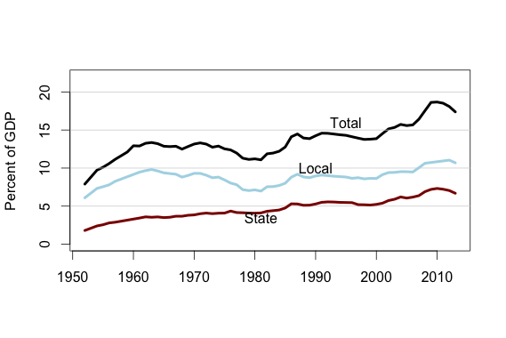
[caption] The figure shows total state, local and combined state-local debt as a share of US GDP.

Figure 1 shows aggregate state and local government debt as a share of GDP. Between 1953 and 2007, state and local debt more than doubled as a share of GDP, from 8 to 18 percent. Both the level and increase in state debt are small relative to other sectors – over the same period household and nonfinancial corporate debt increased from around 25 percent of GDP each in the early 1950s to nearly 100 and 50 percent of GDP respectively. But the scale of state and local debt is not trivial. While smaller than other sectors, state and local balance sheets are in the aggregate large enough to be macroeconomically significant. Debt operates as a political constraint at the state level and often plays a prominent role in public discussions of state budgets.
Equally important, and much less visible in public debate, is the increase in state-local holdings of financial assets over the same period. Figure 2 shows aggregate assets as a share of GDP for state and local governments. From 1953 to 2007, state and local government assets rose from 10 percent to 35 percent of GDP. Pension funds, negligible at the start of the period, accounted for a bit over half of state and local government assets at the end of the period. State pension assets are much larger than local pension assets, reflecting the fact that state governments sponsor pension plans not only for their own employees but for many local government employees as well. More debt is found at the local level, even though state governments account for more combined state-local spending, as shown in Figure 4. This presumably reflects the fact that a disproportionate share of capital spending takes place at the local level.
Figure 2: State and Local Assets as a Share of GDP, 1953-2013
Source: Census of Governments, BEA, author’s analysis.

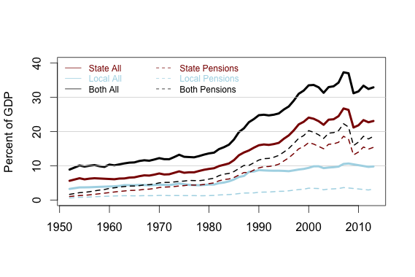
[caption] The figure shows total state, local and combined state-local financial assets as a share of GDP. The heavy lines show all financial assets, including those in pensions and other trust funds; the dotted lines show pension fund assets alone. So the difference between the corresponding dotted and solid line shows non-pension financial assets.

Figure 3: State and Local Net Financial Wealth as a Share of GSP, 1953-2013
Source: Census of Governments, BEA, author’s analysis.

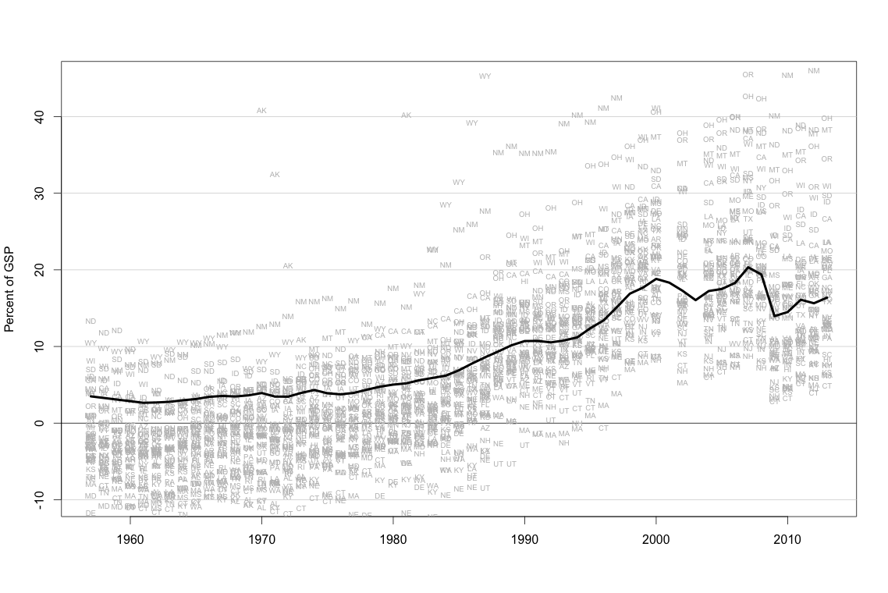
[caption] The solid black line shows net financial wealth (financial assets minus liabilities) for the state-local sector as a whole, as a percent of GDP. The gray symbols show state-local net financial wealth of individual states. Since the mid-1990s, net financial wealth has been positive in all 50 states.

The large rise in state-local asset positions means that, since the mid-1970s, the sector has been a net creditor in financial markets. Since the mid-1990s, both state governments and the consolidated state-local sector has been a net financial creditor in every individual state. These net asset positions are mainly held by state governments: Every state government holds a positive net financial position, most substantial. Aggregated at the national level or at the level of the individual state, local governments hold roughly equal assets and debt. (Of course individual local governments show a wide range of balance sheet positions.) While pension funds account for a large fraction of the shift toward net creditor status, they are by no means wholly responsible for it. Even excluding pension funds, state governments in the aggregate have a substantial positive net asset position. While before 1980 the large majority of state governments were, apart from pension funds, net borrowers in credit markets, in more recent years about two thirds of state governments have positive net financial positions even setting aside assets in pension funds and other trust funds.
Looking at state governments only, the lowest net financial wealth is found in New England, while the highest values are mostly found in Western states. Alaska is an outlier, with net financial wealth exceeding 100 percent of GSP since the mid-1990s – though the 2013 value of 128 percent is down a bit from the 160 percent peak of 1999-2000.
As of 2013, state and local government net financial wealth equaled around 15 percent of GDP, an increase of nearly 20 points relative to its position in the mid-1960s. State and local government net financial wealth exceeded 20 percent of GDP prior to the most recent recession. Of the 8.5-point decline in state-local government net wealth between 2007 and 2009, 6.5 points was due to a fall in assets, thanks to a combination of large capital losses for state and local governments and net sales of financial assets. Only about 2 out of the 8.5-point fall in net financial wealth was due to increased debt.
Again, the long-term rise in state and local net financial wealth is partly, but not entirely, explained by the rise in pension assets. Nonpension assets of state and local governments rose by 8 percent of GDP between 1964 and 2013, about one-third of the 22-point rise in total assets over this period and more than double the 3.5-point rise in debt. The central long-term shift in state and local government balance sheets is a rise in both gross and net assets, not a rise in debt – a fact that is not given sufficient attention in discussion of state and local finances.

Figure 4: State and Local Expenditure as a Share of GDP, 1953-2013
Source: Census of Governments, BEA, author’s analysis.
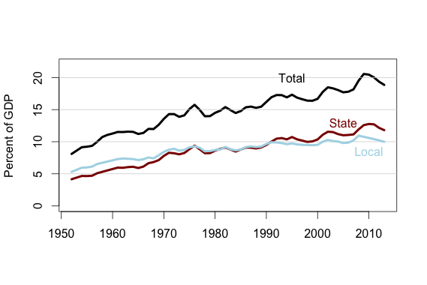
[caption] The figure shows total state, local and combined state-local spending as a share of GDP.
Table 1: State and Local Balance Sheets. All variables are in percent of GSP.
 |  |  | Debt | All Assets | Pensions | Other Trusts | Nontrust Assets
1964 | State | Median | 3.5 | 7.2 | 2.4 | 1.1 | 2.4
 |  | St. Dev. | 2.9 | 2.6 | 1.4 | 0.7 | 2.3
 |  | Total | 3.8 | 7.1 | 3.0 | 1.3 | 2.7
 | Local | Median | 8.8 | 3.3 | 0.3 | 0.0 | 2.9
 |  | St. Dev. | 3.2 | 1.6 | 0.9 | 0.2 | 1.2
 |  | Total | 10.3 | 4.7 | 1.4 | 0.0 | 3.3
2007 | State | Median | 6.6 | 26.9 | 17.9 | 0.6 | 7.6
 |  | St. Dev. | 3.7 | 16.0 | 6.7 | 1.1 | 12.8
 |  | Total | 6.5 | 27.2 | 19.0 | 1.0 | 7.3
 | Local | Median | 8.2 | 8.0 | 0.9 | 0.0 | 6.2
 |  | St. Dev. | 3.4 | 3.4 | 2.5 | 0.1 | 2.1
 |  | Total | 10.2 | 10.8 | 3.7 | 0.0 | 7.0
2013 | State | Median | 6.9 | 23.6 | 14.7 | 0.3 | 7.2
 |  | St. Dev. | 3.6 | 18.8 | 5.4 | 1.2 | 17.4
 |  | Total | 6.8 | 23.5 | 15.7 | 0.7 | 7.2
 | Local | Median | 8.7 | 7.0 | 0.8 | 0.0 | 6.1
 |  | St. Dev. | 3.7 | 3.0 | 2.1 | 0.0 | 2.0
 |  | Total | 10.9 | 10.0 | 3.3 | 0.0 | 6.7

[caption] The table shows five balance sheet variables — debt, total assets, pension fund assets, and non-trust-fund assets — for state and local governments for each of three selected years. For each level of government, the table shows the median value, the standard deviation, and the total for the level as a whole. So for instance, in 1964, the median state had debt equal to 3.5 percent of gross state product, and state governments as a whole had debt equal to 3.8 percent of US GDP.

Table 1 describes the balance sheets of state and local finances for 1964 and 2007. Total assets include retirement funds for public employees (“Pensions”) other trust funds, and assets held by the government directly. All variables are given in percent of gross state product. “Total” rows give the aggregate for that level of government for the US as a whole. Local governments are observed at the state level, not individually. So for instance, in 1964, median state debt was 3.5 percent of GSP and the median state had total local government debt equal to 8.8 percent of GSP.
As Figure 1 and Table 1 show, local governments account for the majority of state and local debt, despite the larger size of state governments as measured by revenue or expenditure. Over the 50 years considered here, local debt has increased only slightly, by less than 2 percent of GDP over the full period. State debt has seen a moderate increase, from 4 percent to 8 percent of GDP.
As shown in Figure 2 there has been a much larger increase in assets – from 5 percent to 11 percent of GDP for local governments, and from 7 percent to 27 percent of GDP for state governments. In contrast to the federal government, the state and local government sectors and most individual governments, have net positive financial positions. For state governments, this is true even excluding funds held in pension systems and other trust funds.

Figure 5: State-Local Revenue and Expenditure as a Share of GDP, 1953-2013
Source: Census of Governments, BEA, author’s analysis.

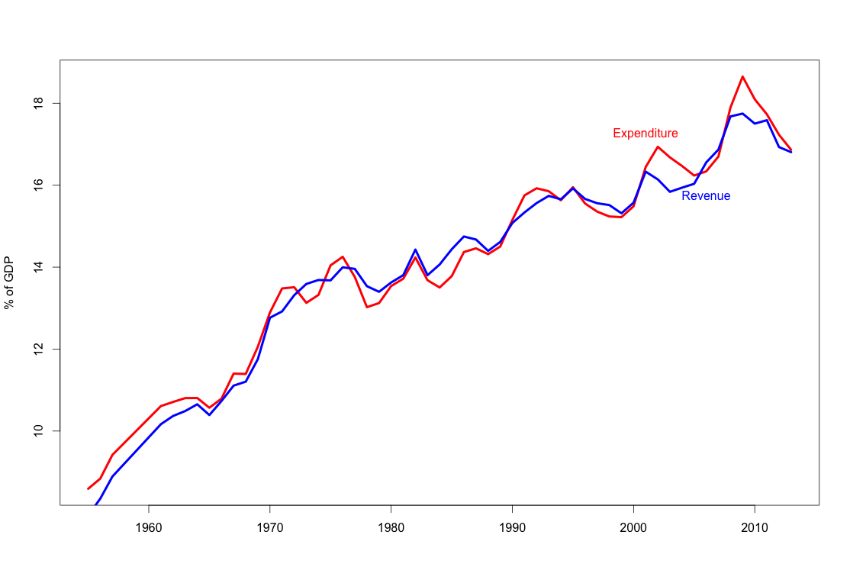
[caption] The figure shows total state-local spending and revenues as a percent of GDP. As it makes clear, the state-local sector does experience substantial fiscal deficits, despite the existence of balanced-budget requirements.

Section 2: Debt Dynamics

When it is observed that an entity’s debt-income ratio rises, it is often assumed that this is because it has spent more on current expenditures than it has received – that it has run a deficit. While this is a natural way of speaking about rising debt ratios, as an matter of accounting it is often incomplete and sometimes even simply false. Debt- Income ratios depend on both debt and income, and debt may be incurred for purposes other than current expenditure. In general, changes in the debt ratio depend not only on current deficits, but also on interest, income growth and inflation. Movements in these other variables, sometimes called “Fisher variables” often swamp any changes in borrowing as a matter of historical fact (Mason and Jayadev, 2014, 2015). Moreover, it is entirely possible to have rising debt levels even if income exceeds current expenditure, if an entity is adding to its assets at the same time. Evolution of debt ratios therefore cannot be understood in a straightforward way as arising out of the difference between current expenditures and current income. Instead, one must account for the full set of factors contributing to the change.
To do this, we can use a linear approximation of the law of motion of debt ratios:
$ΔD=-B+A-g_{N}D-dD$ (1)
$ΔD=-B_{P}+iD+A-g_{N}D-dD$ (2)
$ΔD=-B_{P}+iD+A-(g+π)D-dD$ (3)
In Equations 1 through 3, $D$ is the debt ratio; $B$ is the fiscal balance; $B_{P}$ is the primary fiscal balance; and $A$ is net acquisition of assets; all are normalized by some measure of income, such as GDP. $g_{N}$ is nominal growth rate of that income measure, which can be divided into $g$, the “real” growth rate, and $π$, inflation, measured by some suitable index. $i$ is the average interest rate on outstanding debt, and $d$ is the fraction of debt written off through default. (Default does not play a significant role for state-local debt in the period covered by this paper.) We use the (approximate) accounting identity of Equation 3 to decompose historical changes in state-local debt-GDP ratios into the components on the right-hand side.
As Figure 1 shows, the increase in state debt ratios has not been continuous, but took place in a few distinct episodes in the 1950s, the 1980s and the 2000s. Local debt ratios also increased in these periods, while remaining constant or declining in most other periods. The second of these two periods also saw a large increase in household debt and federal debt. Despite popular perceptions to the contrary, the 1980s-era increases in federal and household debt ratios were not the result of increased new borrowing. Rather, they are fully explained by the combination of sharply falling inflation and continued high interest rates on existing debt, with a modest contribution from slower income growth (Mason and Jayadev, 2015; Kogan et al., 2015) . It is natural therefore to ask whether similar “debt dynamics” explain the rise in state and local debt during this period.
As shown in Table 2, higher interest rates and disinflation are not the main factors in the rise of state and local debt ratios in the 1980s. The reasons are straightforward: Because state and local government debt ratios are much lower than those of the household and federal sectors, the effects of interest rates and inflation on existing debt are less important. Interest rates on state and local debt are also lower and less variable than interest rates faced by households, further reducing their role. But while debt dynamics in the sense of Mason and Jayadev (2014) do not explain the rise of state and local debt ratios in the 1980s and 2000s, neither does the naive story of cumulating budget imbalances. In fact, the state and local sectors shifted toward budget surpluses in the 1980s, after showing small but persistent deficits in the previous period of stable debt ratios. The rise in state and local debt ratios in the 1980s is fully explained – and the rise in the 2000s partially – by a faster pace of asset accumulation.

Table 2: Annual State-Local Debt Ratio Change and Components, Selected Periods
Period | Debt Ratio Change | Growth Contribution | Fiscal Balance | Interest | Trusts and NAFA | Pensions
1955 to 1964 | 0.40 | -0.67 | -0.51 | 0.33 | 0.50 | 0.22
1964 to 1982 | -0.13 | -1.16 | -0.04 | 0.51 | 0.91 | 0.32
1982 to 1987 | 0.61 | -0.91 | 0.38 | 0.83 | 1.80 | 0.41
1987 to 2002 | 0.03 | -0.81 | 0.01 | 0.89 | 0.80 | 0.30
2002 to 2005 | 0.40 | -0.85 | -0.72 | 0.76 | 0.47 | 0.26
2005 to 2007 | -0.03 | -0.91 | 0.01 | 0.69 | 0.84 | 0.29
2007 to 2011 | 0.75 | -0.36 | -0.39 | 0.77 | 0.70 | 0.34
2011 to 2013 | -0.43 | -0.67 | -0.17 | 0.76 | 0.06
1955 to 2013 | 0.13 | -0.86 | -0.14 | 0.64 | 0.79 | 0.31
Source: Census of Governments, BEA, author’s analysis.

Table 2 shows the average annual change in state-local debt-GSP ratios and their components for selected periods. The periods are chosen to distinguish episodes of rising debt ratios from periods of stable or falling ratios. The two periods of most rapid increase are set off from the other lines. (Note that since this is an accounting decomposition rather than a regression, there is no problem with selecting periods this way - there is no danger of “cherry-picking” the results.) Table 2 shows clearly that the periods in which state and local debt ratios increased fastest were not periods of unusually high fiscal deficits at the state and local levels. During the period of rising debt during the 1980s, state and local governments had their highest surpluses of the postwar era. During the period of rapidly rising debt in the late 2000s state and local primary deficits were somewhat larger than the long-term average, but this explains only about a third of the acceleration of debt growth in this period. Rather, the 1980s increase in state and local debt ratios is entirely due to higher rates of asset accumulation, while the 2000s increase is mainly due to slower nominal growth, which subtracted less than 0.4 points from the debt ratio each year, compared with 0.9 points on average over the full period. If state debt-income ratios rose during the recession, it was mainly because income fell, not because borrowing increased. Section 3: Variance Decomposition
We may ask, however, whether this is true more generally. The natural way to assess this is with a covariance matrix. In the case of state budgets, we already know the coefficients an ideal regression would generate. If state spending increases by one dollar, holding all other variables constant, then state debt must increase by one dollar. (Or state assets must fall by one dollar, if that is the dependent variable.) We are interested in how much of the observed historical variation in the variable of interest is explained by the variation in each of the other variables. For this question, we undertake a variance decomposition approach.
Specifically, we know that if
$a=Σb_{n}$then$var(a)=\left({}_{}\right)$$var(a)=Σcovar(a,b_{n})$(4)
Using equation 4, we can precisely decompose the variance of any variable into its covariances with its components. For example, variance decompositions are a well-established tool for distinguishing the between-group and within-group components of changes in income distribution (Shorrocks, 1982) .
In the case of state and local budgets, we can start with the identity that sources of funds = uses of funds. (This is true of any economic unit.) Breaking sources and uses up a bit more, we can write:
$revenues+borrowing=expenditure+netacquisitionoffinancialassets(NAFA)$(5)
(As noted in the Appendix, NAFA is not directly observed, but computed from the other terms in Equation 5.)
We rearrange this to:
$netborrowing=expenditure-revenue+NAFA=fiscalbalance-NAFA$ (6)
Since we are interested in the ratio of debt to income, we write:
$changeindebtratio=netborrowing-nominalgrowthrate$ (7)
This is also an accounting identity, but not an exact one; it is a linear approximation of the true relationship, which is nonlinear. But with annual debt and income growth rates in the single digits, the approximation is very close.
So we have:
$changeindebtratio=expenditure-revenue+NAFA-nominalgrowthrate*currentdebtratio$ (8)
It follows from equation 4 that the variance of change in the debt ratio is equal to the sum of the covariances of the change with each of the right-side variables. In other words, if we are interested in understanding why debt-GDP ratios have risen in some years and fallen in others, it is straightforward to decompose this variation into the contributions of variation in each of the other variables.

Table 3 Covariance Matrix, State-Local Debt Ratio Change and Components
 | Debt Ratio Change | Nominal Growth (-) | Borrow | Fiscal Deficit | Revenue (-) | Expenditure | Interest | Trusts & NAFA
Debt Ratio Change | 0.18 | 0.1 | 0.09 | 0.03 | -0.08 | 0.11 | 0.01 | 0.06
Nominal Growth (-) | 0.1 | 0.11 | -0.01 | 0.04 | -0.24 | 0.28 | 0.01 | -0.05
Borrowing | 0.09 | -0.01 | 0.09 | 0 | 0.12 | -0.13 | 0 | 0.1
Fiscal Deficit | 0.03 | 0.04 | 0 | 0.13 | 0.12 | 0.01 | -0.02 | -0.13
Revenue (-) | -0.08 | -0.24 | 0.12 | 0.12 | 5.98 | -5.86 | -0.42 | 0.01
Expenditure | 0.11 | 0.28 | -0.13 | 0.01 | -5.86 | 5.87 | 0.4 | -0.14
Interest | 0.01 | 0.01 | 0 | -0.02 | -0.42 | 0.4 | 0.04 | 0.02
Trusts and NAFA | 0.06 | -0.05 | 0.1 | -0.13 | 0.01 | -0.14 | 0.02 | 0.23

Source: Census of Governments, BEA, author’s analysis.
[caption] The matrix shows the variance of each item on the main diagonal, with the covariances on the off-diagonal entries. Because the the change in the debt ratio is equal to the fiscal deficit minus nominal income growth plus net asset accumulation, the variance of the debt ratio (0.18) is equal to the covariance of the debt ratio with the fiscal deficit (0.03) minus the covariance with nominal growth (-0.10) plus the covariance with asset accumulation (0.06). This is equivalent to saying that a bit over half the variation in debt-ratio growth is due to variation in nominal income growth, a third is due to variation in asset accumulation, and one sixth is due to variation in the fiscal balance. All values are in percentage points of GSP.

Table 3 gives the covariance matrix for the annual changes in the aggregate state-local debt-GDP ratio and various components for the full 1953-2013 period. Debt ratio change is the year over year change in the ratio of aggregate state-local debt to GDP. Nominal growth refers to the contribution of nominal GDP growth to changes in debt ratios – that is, the variable is growth time the current debt ratio. Since income growth reduces the debt ratio, the signs of the entries for nominal growth are reversed. (This ensures that the variances correspond to the relevant accounting identity.) Borrow is the net increase in debt over the previous year. So the covariance of debt growth with nominal income come growth plus the covariance with borrowing is approximately equal to the variance of debt ratio growth.
Fiscal deficit, expenditure and revenue cover all expenditures and revenues; the deficit is equal to expenditure minus revenue. Interest payments are a subset of expenditure. Trusts and NAFA include all net asset acquisition, including net contributions to pension funds and to other trust funds as well as financial assets acquired directly by the government.
Since the table uses the contribution of GDP growth, rather than GDP growth itself, the covariances of this variable with the other non-debt variables is not meaningful. All the other covariances can be interpreted in a straightforward fashion. So for instance, we see that a bit less than a tenth (0.40 out of 5.87) of the variation in state-local expenditure over time is accounted for by variation in interest payments. Also note, the sign is reversed for variables that reduce the debt-GDP ratio, indicated with (-) after the variable.
Table 3 presents several of the central findings of this paper. It shows several important patterns in the annual variation in state and local government balance sheets and income and expenditure flows.
- At an annual frequency changes in the debt ratio are driven about equally by growth of the numerator and of the denominator. About a half (0.09 out of 0.18) of the variation in annual changes in the debt ratio comes from the variation in debt growth, and just over half (0.10 out of 0.18) comes from variation in the growth rate of nominal income.
- Of the half, the variation in debt ratio growth that comes from new borrowing, only one third of (0.03 out of 0.09, out the total 0.18 variance in annual debt growth) comes from fiscal imbalances. Two thirds of the variation in new borrowing (0.06 out of 0.09) comes from variation in the pace of net acquisition of financial assets. In other words years in which state government debt ratios are rising because of higher borrowing, are more often years of rapid asset growth than of large deficits.
- Variation in state-local fiscal balances is driven almost entirely by variation in revenue, not expenditure. Of the 0.13 variance in fiscal balances, 0.12 comes from revenue and 0.01 comes from expenditure. Note also that the large variance of state revenues and expenditures are almost entirely shared between the two variables. (The sign on the covariance is reversed because higher revenue subtracts from the debt ratio, as noted above.) This means that, over the 60 years covered in the data, the large variation in the overall size of the state-local sector almost all involves revenues and expenditure rising (or occasionally falling) together – a pattern also visible in Figure 5.
- Variation in interest payments does not account for a significant share of variation in either debt ratio growth or fiscal balances. As noted earlier, this is an important difference from the household sector.
These points are brought out more clearly in Tables 4 and 5. These tables present the same basic data as Table 3, but they show only the covariances for debt ratio growth and fiscal balances, and they scale the covariances by the variance of debt growth in Table 4 and the fiscal balance in table 5. So, the entries are the share of the total variance of aggregate debt ratio growth and fiscal balance, respectively, accounted for by each of the other variables. Tables 4 and 5 also show the same values for the state sector alone, as well as for the consolidated state-local sector used in Table 3.

Table 4 Variance Decomposition of State-Local Debt Ratio Growth
Component | State + Local | State Only
Nominal Growth (-) | 0.52 | 0.30
Fiscal Balance (-) | 0.17 | 0.31
Revenue (-) | -0.41 | 0.07
Expenditure | 0.58 | 0.24
Interest | 0.06 | 0.03
Trusts & NAFA | 0.33 | 0.37

[caption] The entries here show the covariances from the first column of Table 3, divided by the variance of debt ratio growth. In other words, it shows the fraction of the variance of debt ratio growth is accounted for by each of the other variables. The negative value for revenue under “state + local” means that state and local revenue was higher as a share of GDP in years in which debt ratios were rising, than in years in which they were falling.

Source: Census of Governments, BEA, author’s analysis.
Table 4 shows, again, that 52 percent of the historical variation in state-local debt ratio growth comes from variation in nominal income growth, 33 percent comes from variation in the pace of asset accumulation, and only 17 percent comes from variation in the fiscal balance. For state governments alone, the fiscal balance plays a larger role; this is not surprising, since state governments have more capacity than most local governments to run temporary budget imbalances and to accommodate them through borrowing. Although as we will see in a moment, even state governments make very little use of debt for this purpose.
Table 5 addresses a slightly different question: Historically, what has driven budget imbalances at the state-local level, and how have they been accommodated? The answers to these questions are unambiguous. For both the consolidated state-local sector and state governments alone, all the variation in the fiscal balance comes from the revenue side; variation in expenditure plays a minor role for local governments and no role at all for state governments. Table 5 breaks out two components of revenue not reported in the earlier tables, taxes and intergovernmental transfers. (These are not the only revenue categories, so the two lines don’t sum to revenues.) For state governments, the revenue contribution to the fiscal balance comes almost entirely from variation in the tax take, but for the consolidated sector, intergovernmental revenues and other non-tax revenues also contribute. The bottom half of the table shows how fiscal imbalances are accommodated on the balance sheet. For the consolidated sector, the answer is: entirely on the asset side. Historically, one hundred percent of the variation in state-local fiscal balances is shared with variation in the pace of net asset accumulation; none of the variation is shared with borrowing.

Table 5: Variance Decomposition of State-Local Fiscal Balance
Component | State + Local | State Only
Revenue | 0.94 | 1.01
Taxes | 0.5 | 0.93
Intergovernmental | 0.18 | -0.04
Expenditure (-) | 0.06 | -0.01
Trusts & NAFA | 1.04 | 0.92
Pensions | 0.1 | -0.49
Borrowing (-) | -0.04 | 0.08

[caption] The entries here show the covariances from the fourth column of Table 3, divided by the variance of the fiscal balance. In other words, it shows the fraction of the variance of the budget position that is accounted for by each of the other variables. The fact that the revenue value is close to one means that essentially all the variation in aggregate state and state-local budget positions is driven by changes in revenue. Similarly, the values close to zero for borrowing show that at an annual frequency, essentially none of the variation in aggregate budgets is accommodated by changes in borrowing.

A few other noteworthy facts about the historical evolution of state and local finances emerge from Tables 4 and 5. First, we see that the mid-1980s increase in state and local debt ratios was somewhat atypical. During that period, a rise in debt ratios coincided with a shift in aggregate state and local budgets toward surplus, and with an even larger increase in state and local asset positions. But as the positive values for fiscal balance Tables 4 and 5 shows, over the full period rising state debt ratios did coincide with less positive state fiscal balances. This is not true of local governments in isolation (not shown), where the covariance is essentially zero. Second, for the state sector, the variance of fiscal positions and of net additions to assets are much larger than the variance of changes in debt, and almost entirely shared with each other. In other words, for the state government sector, unlike the federal government, annual variation in the fiscal position is almost entirely accommodated on the asset side of the balance sheet. As we will see, this is true at a disaggregated level as well. Third, a substantial majority of variation in state government fiscal positions (about five-sixths) is the result of variation in revenue, rather than variation in expenditure. We may summarize the results as follows: About two-thirds of historical variation in state and local debt growth reflects changes in borrowing (the numerator) while one third of the variation reflects changes in the growth rate of income (the denominator).
The budget and balance sheet of the local government sector in isolation behave somewhat differently. Aggregate local government expenditure and revenue move together much more closely than do expenditure and revenue at the state level. The standard deviation of the aggregate local fiscal balance is just 0.2 percent of GDP, compared with 1.1 percent of GDP for the aggregate state fiscal balance. And at the local level, fiscal deficits play no role in changes in the debt ratio. Just under 50 percent of variation in debt growth is due to variation in income growth, while just over 50 percent is due to variation in asset accumulation; variation in the fiscal position makes a negligible contribution. At the state level, faster debt growth goes along with faster asset accumulation only during the 1980s; at the local level, this is true for the full period. For the local government sector an increase in credit-market borrowing has historically been associated with a slightly larger increase in accumulation of financial assets, so that higher gross borrowing is associated with higher net financial saving.
In the next section, we look at variation across states.

Section 4: Cross-State Variation
It is possible in principle for aggregate debt changes to be weakly correlated with aggregate fiscal position but for the relationship to be stronger at the level of individual governments. It could be that in each period, some governments are running large deficits and adding debt, while other governments are running surpluses and accumulating assets. In the aggregate level, it would then appear that borrowing was independent of real spending and revenue, even if it was fully explained by it at the level of individual governments. As it turns out, though, this is not the case. Much, though not all, of the variation across states in borrowing, has been driven by differences in the pace of asset accumulation. (This is especially true in the period of rapidly rising state debt in the 1980s.) And at the level of individual state governments, fiscal imbalances are almost entirely accommodated on the asset side of the balance sheet, just as they are for the sector.
The first set of results are shown in Figure 6 This shows the variance of the change in state debt-GSP ratios by year and the decomposition into its covariances with the contribution of nominal GSP growth, net acquisition of financial assets and the fiscal deficit. (The sign is reversed for the growth contribution, since this is a subtraction from the debt ratio.) So the value of the latter three lines are the contributions of variation in each of those three variables to cross-state variation in the change in debt-GSP ratios. As can be seen, the role of net asset accumulation is overwhelming. During the period of increasing state debt in the 1980s, more than all the variation across states in debt ratios is driven by different rates of asset accumulation. Different rates of GSP growth and, especially, fiscal balances tended to offset the observed differences in debt ratio growth. During the last full expansion (2001-2007), variation in fiscal balances explained a larger fraction of variation in debt growth – almost 30 percent – but variation in asset accumulation still accounted for over 60 percent. (Variation in growth rates again accounted for 10 percent.) Only since 2007 is the cross-state variation in debt ratio growth consistently is accounted for by variation in fiscal deficits.

Figure 6: Variance Decomposition, Changes in State Debt-GSP Ratio, 1964-2013
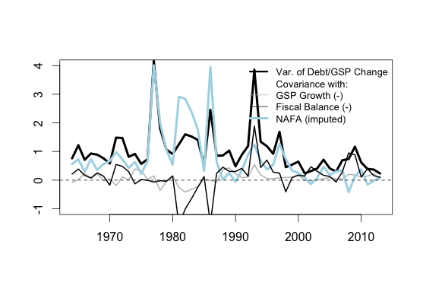
Source: Census of Governments, BEA, author’s analysis.

Thus, state balance sheets show two different kinds of behavior, historically. Into the 1990s, the main source of financial pressure is the need to increase prefunding of pension obligations and other future expenditures. This pressure means that state and local governments might find themselves borrowing even while running substantial surpluses; in some cases, public employers even borrowed explicitly in order to make additional contributions to trust funds. (A good discussion of this seemingly perverse behavior is found in Sgouros (2017).) During the 1980s there was a strong positive relationship between fiscal surpluses and debt growth. More recently, asset accumulation has evidently ceased to be such a source of autonomous financial pressure on state and local governments, and there has been a more “normal” negative correlation between the fiscal balance and debt growth. The contrast between these two periods is shown in Table 6, which decomposes the variance in debt growth across states in two different episodes of rising debt ratios.

Table 6: Decomposition of across-State Debt-Growth Variance, Two Periods
 | 1981-1986 | 2008-2010
SD of Debt Ratio Change | 0.44 | 0.29
Share of Variance Attributable to
Nominal Growth (-) | -0.11 | 0.05
Borrowing | 1.06 | 0.94
Fiscal Balance (-) | -0.47 | 0.77
Revenue (-) | -2.18 | 1.38
Expenditure | 1.71 | -0.61
Trusts and NAFA | 1.53 | 0.16
Source: Census of Governments, BEA, author’s analysis. The analysis here excludes Alaska.

[caption] The first row of the table shows the standard deviation of state debt ratio growth across states in the two periods given. The remaining rows decompose this variation into the contributions of each of the items given. Negative values means that this factor was reducing variation across states, positive entries mean that it was increasing it. The negative value for revenue in the 1981-1986 column means that during this period, the states with the fastest growing debt ratios also had the highest revenue as a share of GSP, and that this shared variation was about twice as great as the variation in debt growth itself.

The first line of Table 6 shows the standard deviation of average annual debt-ratio growth across states in the two periods. As can be seen, debt growth varied somewhat more across states in the 1980s than in the great recession period. In both periods, debt ratio growth was explained entirely (the 1980s) or almost entirely (2008-2010) by different levels of borrowing across states. While the pace of nominal income growth is very important for changes in aggregate debt ratios, it does not play an important role in the dispersion of debt ratios across states.
In other respects, however, the two periods are quite different. In the more recent period, about three quarters of variation in borrowing across states reflects differences in state budget positions. In the 1980s, less than none of it does. Roughly speaking, during 2008-2010, a state with one extra percentage point of GSP of borrowing had a budget 0.77 points further toward deficit. In the 1980s, however, a state with an extra point of borrowing had a budget 0.47 points further toward surplus. This is explained by the fact that, during the 1980s, the states adding debt the fastest were also adding assets the fastest: one percent of GSP of additional borrowing was associated with a 1.53 points additional asset accumulation.

Figure 7: Aggregate State Financial Balances, 1999-2013

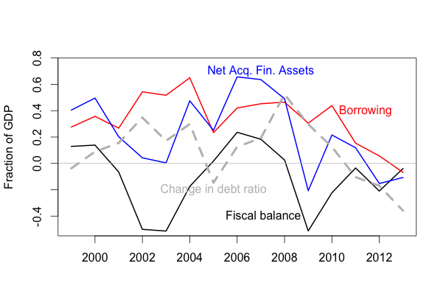
Source: Census of Governments, BEA, author’s analysis.
[caption] The figure shows the aggregate debt ratio change, fiscal balance, net acquisition of financial assets and credit-market borrowing for state governments over 1999-2013. As the figure shows, while the Great Recession period saw both a substantial shift toward state-level fiscal deficits (despite notional balanced-budget requirements) and a rise in debt ratios, there was no direct link between these developments, since credit-market borrowing did not rise.

Even in the more recent period, where credit-market borrowing across states does reflect their fiscal balances, the relationship between the two is not direct. The great majority of state fiscal imbalances continue to be accommodated on the asset side. Figure 7 shows total borrowing (red), net acquisition of financial assets (blue), and the overall fiscal balance (black, with surplus as positive) for state governments during the last two business cycles. It also shows the year over year change in the ratio of state debt to GDP (the gray dotted line). As the figure makes clear, there was no increase in aggregate state government borrowing during the most recent recession. The entire rise in the ratio of state government debt to GDP during this period (about two points in total) is due to slower income growth. Again, as Table 6 shows, such a strong claim is not true at the disaggregated level: Variation in borrowing across states during the recession period was substantially driven by the differences in budget gaps. But it is still the case that the great bulk of financing for budget gaps came on the asset side of state government balance sheets. This is shown in Table 7.

Table 7: Decomposition of Across-State Variance in Budget Positions, 2009-2012
Revenue | 1.13
Taxes | 0.69
Intergovernmental | 0.34
Expenditure (-) | -0.13
Interest | 0.01
Borrowing (-) | 0.06
Trusts and NAFA | 0.94

[caption] The entries show the share of cross-state variance in state fiscal balances accounted for by each of these components. The fact that the entry for revenue is greater than one means that differences in revenue account for more than all of the variation in fiscal balances; states with faster debt ratio growth have lower expenditure as a share of GSP than states with slower debt ratio growth.

Table 7 decomposes the variance in state fiscal balances during 2009-2012 on two dimensions.
The first decomposition is into expenditure and revenue, with some subcomponents of each. The second decomposition is into borrowing and net acquisition of financial assets (including trust fund contributions). Any budget imbalance must ,by definition, be equal both to the difference between revenue and expenditure, and to the difference between net borrowing and net acquisition of financial assets. So, the variance of the fiscal balance across states can be decomposed into its covariances with each of these pairs of components. The “(-)” after Expenditure and Borrowing indicates that these are components that move inversely with the fiscal balance.
Table 7 shows two clear patterns in the variation state fiscal balances across states during the Great Recession period. (Note that the dates here are slightly different from in Table 6], because, as can be seen in Figure 7 the periods of rising state debt and of state budget deficits do not exactly coincide.) First, variation in state budget deficits is entirely driven by variation in revenue; states with larger deficits had somewhat lower spending as a share of GSP. (This is shown by the negative value for expenditure.) Second, variation in fiscal positions is reflected almost entirely in variation in the pace of asset accumulation, with borrowing playing only a minor role. On average, a state that had an additional one percent of state product deficit during 2009-2012, financed it by reducing purchases of financial assets by 0.94 points, and increased borrowing by only 0.06 points. As can be seen by comparison with Table 5 these are almost identical to the results we saw for variation in the aggregate state budget position over time. So, while variation in debt-ratio growth looks somewhat different across time versus across states – with nominal income growth much more important in the former case – variation in state fiscal positions looks essentially the same across both dimensions.

Conclusion
There is a strong assumption, often implicit, that financial positions can be treated as a record of book-keeping for real activity. This idea grows naturally from a vision of an economy as consisting fundamentally in terms of “real exchange” of goods and services, with monetary and financial developments reflecting, or at least built on, an underlying nonmonetary economy. From this perspective, for instance, it is natural to identify credit-market borrowing with dissaving, and the increase in financial wealth with saving. It is also natural to ignore gross positions and focus on net ones – or, often, to treat gross positions as if they were net. In this paper, we suggest that this “real exchange” perspective will have trouble making sense of central developments in public balance sheets over the past 50 years. Variation in debt ratios, both over time and across jurisdictions, is not straightforwardly linked to real income and expenditure flows.
This paper also makes a methodological argument: When the goal is to describe the concrete historical behavior of variables linked by known accounting relationships, some form of historical accounting decomposition should be used. We argue that to understand how state debt ratios, asset accumulation and fiscal positions have been linked historically, a variance decomposition is a suitable tool. To our knowledge, this paper is the first to attempt to understand the evolution of state and local balance sheets using a variance decomposition methodology.
The straightforward link between public budget positions and public debt ratios assumed by the studies discussed in Section 1 is complicated by two factors. First, some of the variation in the debt ratio comes from different rates of nominal income growth, rather than different levels of borrowing. And second, state and local balance sheets include substantial assets as well as debts. This latter fact modifies the relationship between current budget positions and borrowing in two contradictory ways. On the one hand, asset positions allow imbalances between current spending and revenue to be accommodated without resort to the credit markets. This tends to reduce both the level and variation in debt growth, and implies a negative relationship between borrowing and net asset accumulation, since budget shortfalls will be met by some mix of increased net and reduced asset accumulation. On the other hand, if state and local governments feel pressure to increase their asset positions, this can lead them to borrow more than they otherwise would. Financial assets may be financed directly with new borrowing, as with Pension Obligation Bonds (Norcross, 2010; Weiner et al., 2013) . Or the pressure to set aside funds for asset accumulation may lead capital projects and other spending to rely more heavily on debt financing than they would otherwise. Either way, this second relationship between the two sides of the balance sheet will increases both the level and variation of debt growth, and tend to produce a positive relationship between asset and debt growth.
In fact, both these relationships between public assets and public debt can be found in the data. From the 1950s through the 1990s, the second relationship dominated, with debt growth across states positively correlated with both asset growth and with the fiscal balance. This is especially true in the 1980s - the period of most rapid increase in state-local debt ratios. During this decade, there was a strong positive relationship between the fiscal balance and debt growth - exactly the opposite of what one would naively expect. This implies that debt growth in this period was driven mainly by increased pressure to prefund future expenses, rather than by current revenue shortfalls. Over the 1990s, however, the cross-state correlations between debt growth, asset accumulation and fiscal balances evidently reversed. In more recent years, states with more rapid debt growth typically have fiscal deficits and are decumulating assets, indicating that pressure to increase prefunding has no longer been the dominant factor in debt growth. At the same time, the largest part of fiscal imbalances continues to be accommodated on the asset side. Thus, while more recent changes in debt growth across states do reflect variation in their fiscal positions, it is still the case that there is not a tight link between the current budget position and the level of borrowing.
The aggregate relationships, meanwhile, show all these factors at work. For both state governments and the consolidated state-local sector, periods of faster debt-ratio growth are due mostly to slower nominal income growth, secondly to faster asset accumulation, and only third (but still positively) by current deficits. Like the cross-state data, the aggregate data shows that budget imbalances are overwhelmingly accommodated on the asset side of state-local balance sheets, not through credit-market borrowing. A natural next step for policy discussions, therefore, is the asset side of state and local balance sheets. Conventional opinion holds that unfunded pension obligations should be treated as liabilities, so that incurring debt to acquire pension fund assets leaves the balance sheet unchanged. We have not taken this view in the current paper. It is far from obvious why future payments to retired public employees require full advance funding, any more than any other predictable future expenses do. (Sgouros 2017) The question of what to prefund is a political and policy question, not an accounting one. The degree to which it is prudent or rational to prefund pension obligations and other future expenses requires much more critical attention than it usually receives.

Appendix: Notes on Data
A challenge in working with the census data is the treatment of public employee pension funds and other trust funds. Public employee retirement funds account for about half the assets reported for state and local governments. In its accounts of state and local government finance, the Bureau of the Census consolidates such funds with the finances of the sponsoring government. This is different, for instance, from the treatment of state and local governments and public employee retirement systems as distinct sectors within the Financial Accounts.
In this paper, we adopt a compromise position between the fully consolidated approach of the Census of Governments and the fully arms-length approach of the Financial Accounts, in a way that attempts to match the way trust funds are typically treated in policy discussions. We do consider pensions and other trust funds as part of the overall assets of the state and local government sector. But we break them out from other assets, reporting pensions and non-trust assets separately. (Non-pension trusts can conceptually be grouped on either side, but are not quantitatively significant.) Because the census consolidates trusts with the sponsoring governments, it counts income generated by trust assets as revenue of the sponsoring government, and counts that income as part of the sponsor’s contribution to the fund. To match conventional usage, we net out pension income from both these flows. That is, we follow conventional practice and do not count trust income as a contribution from the sponsoring government. Contributions, here, include only additions to funds from the sponsor’s non-trust revenue. Similarly, while the census counts benefits paid out from pension funds and other trust funds as part of the sponsoring government’s expenditure, here we net those payments out. Consistent with standard practice in most contexts, state and local government spending here does not include trust fund benefits payments. Administrative expenses are however counted with government expenditure; these expenses are an order of magnitude smaller than benefits payments and play no role in the results. So our headline measure of “net accumulation of financial assets” includes contributions to pensions and other trust funds by the sponsoring government; but it does not include assets purchased with employee contributions or the reinvested earnings of the fund.
A separate question is whether estimates of the implicit pension liabilities to retired pubic employees should be included as liabilities. Federal accounting standards now require the present values of future pension payments be reported as a liability by public employers, despite clear differences between pension commitments and credit-market debt. The census makes no attempt to do so, but reports only directly observable cashflow and balance sheet values. we follow the census in out analysis, but discuss the conceptual issues further below. Along the same lines, one might also wish to include nonfinancial assets - real estate; plant and equipment; intellectual property – on public-sector balance sheets, along with financial assets. Again, the census makes no attempt to do so, and we follow the census here. There are reasons to be skeptical that any such value would be meaningful, since by their nature most “real assets” of the public sector have no private market. Our focus here is strictly on financial assets and liabilities which can be observed directly on public-sector balance sheets.
A final problem is that net acquisition of financial assets (NAFA) is not observed directly in the data. Closing asset positions are reflected, but these are, of course, affected by capital gains or losses as well as by net acquisition of assets. So net acquisition of assets is defined as a residual – all sources of funds minus all reported uses. Since any unspent funds must be held in the form of some asset, as long as other flows are reported correctly this residual should be exactly equal to true NAFA. While we cannot exclude the possibility that our reported NAFA is affected by errors in reporting, our measure is consistent with the reported asset positions plus a plausible rate of capital gains.

References
Bernanke, Ben S. 2011. “Challenges for state and local governments.” speech at the 2011 Annual Awards Dinner of the Citizens Budget Commission, New York, New York, 2.
Bifulco, Robert, Beverly Bunch, William Duncombe, Mark Robbins, and William Simonsen. 2012. “Debt and Deception: How States Avoid Making Hard Fiscal Decisions.” Public Administration Review, 72(5): 659 – 667.
Brown, Jeffrey R., and Richard F. Dye. 2015. “Illinois Pensions in a Fiscal Context: A (Basket) Case Study.” National Bureau of Economic Research Work- ing Paper 21293.
Edwards, Chris. 2006. “State and local government debt is soaring.” Cato Institute Tax and Budget Bulletin, , (37).
Garrett, Thomas A, et al. 2011. “State balanced-budget and debt rules.” Eco- nomic Synopses.
Heintz, James. 2009. “The Grim State of the States: The Fiscal Crisis Facing State and Local Governments.” Vol. 18, 7, Sage Publications Ltd.
Kogan, Richard, Chad Stone, Bryann DaSilva, and Jan Rejeski. 2015. “Difference Between Economic Growth Rates and Treasury Interest Rates Sig- nificantly Affects Long-Term Budget Outlook.” Center for Budget and Policy Priorities.
Leijonhufvud, Axel. 2008. “Between Keynes and Sraffa: Pasinetti on the Cam- bridge School.” The European Journal of the History of Economic Thought, 15(3): 529–538.
Maquire, Steven. 2011. “State and local government debt: An analysis.”
Mason, J. W., and Arjun Jayadev. 2014. ““Fisher Dynamics” in US Household Debt, 1929-2011.” American Economic Journal: Macroeconomics, 6(3): 214–234.
Mason, J. W., and Arjun Jayadev. 2015. “The post-1980 debt disinflation: an exercise in historical accounting.” Review of Keynesian Economics, 3(3): 314–335. 30
Mehrling, Perry. 2012. “A Money View of Credit and Debt.” INET Working Paper.
National Association of State Budget Officers. 2008. “State Balanced Budget Requirements: Provisions and Practice.” Washington, D.C.: NASBO
Norcross, Eileen. 2010. “Fiscal Evasion in State Budgeting.” Working Paper.
Ricketts, Lowell R, Christopher J Waller, et al. 2012. “State and local debt: growing liabilities jeopardize fiscal health.” The Regional Economist.
Rosnick, David, and Dean Baker. 2012. “Pension Liabilities: Fear Tactics and Serious Policy.” Center for Economic and Policy Research.
Sgouros, Tom. 2017. “Funding Public Pensions.” Haas Institute.
Shorrocks, Anthony F. 1982. “Inequality decomposition by factor components.” Econometrica: Journal of the Econometric Society, 193–211.
Weiner, Jennifer, et al. 2013. “Assessing the affordability of state debt.” Federal Reserve Bank of Boston.
Wilcox, David. 2009. “Municipal finance: testimony before the Committee on Financial Services, U.S. House of Representatives, May 21, 2009.” Board of Governors of the Federal Reserve System (U.S.) Web Site 58.

Some technical issues involving the Census data are discussed in the appendix.
For example, see Brown and Dye (2015).
The Financial Accounts and most other national accounts do not count assets of pension funds (and some other, smaller trust funds) as assets of the sponsoring governments, so report much lower financial assets for state and local governments.
It is interesting that despite this, Alaska state government debt is also well above the national median. This is an important reminder that we cannot assume that net and gross positions vary together.
For a critical view of the treatment of future pension payment as a current liability, see Rosnick and Baker (2012).

